Belief Systems

* A set of beliefs, especially religious or political beliefs, that form a unified system

Ex.

Absolutism

* A political theory and form of government where unlimited, complete power is held by a centralized sovereign individual, with no checks or balances from any other part of the nation or government.

Ex. Monarchy, Divine Right, Bishop Jacques-Benigne Bossuet, King Louis XIV, Peter the Great

Anti-Semitism

* Hostility, and prejudice toward Jews

Ex. Nazi Germany, The Third Crusade, Blaming Jew for poisoning wells, Fundamentalist Islamic countries

Agricultural

* Relating to agriculture, which the cultivation of animals, plants and fungi for food, fiber, biofuel, medicinal plants and other products used to sustain and enhance human life

Ex.

1

2

Capitalism

* A free and open market where the demand for their goods and services would determine their prices and availability

Ex.

Buddhism

* A religion where adherents follow the Four Noble Truths to move toward the nirvana, the state of perfect peace and harmony

Ex. Karma, Theravada, Mahayana, Vajrayana

Calvinism

* A major branch of Protestantism that follows the theological tradition and forms of Christian practice of John Calvin and other Reformation-era theologians

Ex.

Bureaucracy

* A way of organizing government tasks by department, or bureau

Ex.

Communism

* A political theory derived from Karl Marx, advocating class war and leading to a society in which all property is publicly owned and each person works and is paid according to their abilities and needs

Civilization

* The stage of human social development and organization that is considered most advanced

Ex.

Commerce

* An interchange of goods or commodities on a large scale between different countries or between different parts of the same country trade or business.

Colonization

* An ongoing process of by which a central system of power dominates the surrounding land and its components

Ex.

3

4

Dadaism

* A nihilistic art movement (especially in painting) that flourished in Europe early in the 20th century; based on irrationality and negation of the accepted laws of beauty

Ex.

Confucianism

* A political and social philosophy dealing with the question of how to restore political and social order, focusing on five fundamental relationships, the formation of junzi, and the values of *Ren*, *Li*, and *Xiao*

Ex. Confucius,

Cubism

* An early 20th-century style and movement in art, especially painting, in which perspective with a single viewpoint was abandoned and use was made of simple geometric shapes, interlocking planes, and, later, collage

Ex.

Creationism

* The religious belief that the universe and life originated from specific acts of divine creation

Ex.

Deism

* A belief system believing in a powerful god who created and presided over an orderly realm but who did not interfere in its workings

Ex.

Daoism

* A belief system based on an elusive concept regarding an eternal principle governing all the workings of the world, defined as the way of nature and the way of the cosmos

Ex.

Decolonization

* The undoing of colonialism, where a nation establishes and maintains its domination over dependent territories

Ex.

Darwinism

* The strong should see their wealth and power increase while the weak should see their wealth and power decrease, more productive people live in the temperate regions

5

6

Empire

* An extensive group of states or countries under a single supreme authority

Ex.

Demographic

Ex.

Egalitarianism

* A trend of thought that favors equality for all people, all humans are equal in fundamental worth or social status

Ex.

Diffusion

* The movement of ideas, notions, and innovations

Ex.

Fascism

* A political system where the main idea was to destroy the will of the individual in favor of the people; wanting a unified society, pushing for nationalism

Ex.

Environmental

* Relating to the natural world and the impact of human activity on its condition

Ex.

Existentialism

* A philosophical theory or approach that emphasizes the existence of the individual person as a free and responsible agent determining their own development through acts of the will.

Ex.

Environmentalism

* A broad philosophy, ideology, and social movement regarding concerns for environmental protection and improvement of the health of the environment, particularly as the measure for this health seeks to incorporate the concerns of non-human elements

Ex.

7

8

Gender Roles

* The role or behavior learned by a person as appropriate to their gender, determined by the prevailing cultural norms

Ex.

Feminism

* The advocacy of women's rights on the grounds of political, social, and economic equality to men

Ex.

Fundamentalism

* Strict adherence to the basic principles of any subject or discipline:

Ex.

Feudalism

* A social, economic, and political system of the Middle ages where people were divided up into several social classes including the king, nobles, vassals, peasants, and fiefs

Ex.

Humanism

* Focusing on life on Earth and celebrating human achievements in the scholarly, artistic, and political realms

Ex.

Globalization

* The process of international integration arising from the interchange of world views, products, ideas and other aspects of culture

Ex.

Hinduism

* An religion where adherents believe in one supreme force, Brahma, and their main life goal is to merge with Brahma over the course of several lifetimes

Ex.

Hierarchy

* A system or organization in which people or groups are ranked one above the other according to status or authority

Ex.

9

100

Interactions

* The action or influence of things on one another

Ex.

Ideology

* A collection of beliefs held by an individual, group or society. a set of conscious and unconscious ideas which make up one's beliefs, goals, expectations, and motivations.

Ex.

Impressionism

* A 19th-century art movement that originated with a group of Paris-based artists whose independent exhibitions brought them to prominence during the 1870s and 1880s

Ex.

Imperialism

* A policy of extending a country's power and influence through diplomacy or military force

Ex.

11

Legalism

* A belief system where adherents don’t trust human nature, advocate the need for tough laws, believe that people would be made to obey through harsh punishment, strong central government, and unquestioned authority, and focused only on things that were practical or that sustained the society

Ex.

Isolationism

* A policy declared by a country announcing neutrality in a war and preferring to focusing on its own internal affairs

Ex.

Labor Systems

Ex.

Judaism

* A religion where adherents believe that God selected a group of people, the Hebrews, and if they followed his laws, worshipped him, and were faithful, he would preserve them for all time

Ex.

12

Materialism

* A tendency to consider material possessions and physical comfort as more important than spiritual values

Ex.

Manicheism

* A dualistic religious system with Christian, Gnostic, and pagan elements

Ex.

Marxism

* The political and economic theories of Karl Marx and Friedrich Engels, later developed by their followers to form the basis for the theory and practice of communism

Ex.

Maritime/Maritime Trade

* Trade that is done through shipping goods from a port in country or city to another

Ex.

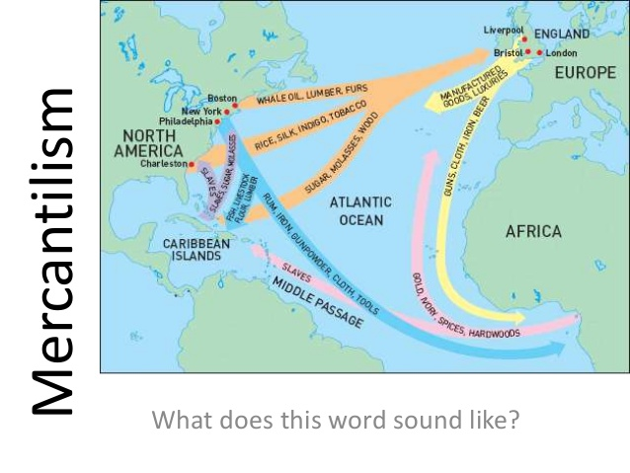

13

Monotheism

* The doctrine or belief that there is only one God

Ex.

Mercantilism

* Actively seeking to trade, but not importing more than exporting; attempting to create a favorable balance of trade

Ex. Nations of Europe starting in the 1500s, Colonies, Triangular Slave Trade, Opium War

Modernism

* A philosophical movement that, along with cultural trends and changes, arose from wide-scale and far-reaching transformations in Western society in the late 19th and early 20th centuries

Ex.

Militarism

* The belief or desire of a government or people that a country should maintain a strong military capability and be prepared to use it aggressively to defend or promote national interests

Ex.

14

Neo-Confucianism

* An attempt to create a more rationalist and secular form of Confucianism by rejecting superstitious and mystical elements of Taoism and Buddhism

Ex.

Nation-Building

* The process of constructing or structuring a national identity using the power of the state

Ex.

Nationalism

* The desire of a people of a common cultural heritage to form an independent nation-state and/or empire that both represents and protects their shared cultural identity

Ex.

Nation-States

* A type of state that conjoins the political entity of a state to the cultural entity of a nation

Ex.

15

Polytheism

* The belief in or worship of more than one god

Pacifism

* Opposition to war, militarism, or violence

Pantheism

* The belief that the Universe is identical with divinity, or that everything composes an all-encompassing, immanent god

Pandemic

* An epidemic of infectious disease that has spread through human populations across a large region

16

Revolution

* A forcible overthrow of a government or social order in favor of a new system

Racism

* Prejudice, discrimination, or antagonism directed against someone of a different race based on the belief that one's own race is superior

Reform

* Make changes in something (typically a social, political, or economic institution or practice) in order to improve it

Realism

* The doctrine that universals or abstract concepts have an objective or absolute existence

17

Skepticism

Romanticism

* A movement in the arts and literature that originated in the late 18th century, emphasizing inspiration, subjectivity, and the primacy of the individual

Scholasticism

* A method of critical thought which dominated teaching by the [academics](https://en.wikipedia.org/wiki/Academics) of [medieval universities](https://en.wikipedia.org/wiki/Medieval_university) in Europe from about 1100 to 1700, and placed emphasis on dialectical reasoning (the exchange of argument),  thesis(an counter argument), or antithesis, (synthesis), directed at answering questions or resolving contradictions.

Ex.

Schism

* A split or division between strongly opposed sections or parties, caused by differences in opinion or belief

Ex. The Great Schism

188

Surrealism

* A 20th-century avant-garde movement in art and literature that sought to release the creative potential of the unconscious mind, for example by the irrational juxtaposition of images

Social Darwinism

* Dominant races or classes of people rose to the top through a process of survival of the fittest

Socialism

* A political and economic theory of social organization that advocates that the means of production, distribution, and exchange should be owned or regulated by the community as a whole

Social Revolution

19

Utilitarianism

Terrorism

* The use of violence and intimidation in the pursuit of political aims

Trade Network

Totalitarianism

* A political belief system where the dictator rules absolutely, controlling every aspect of life, with “total” control